Sebastián Pecznik
Guitarist | Composer | Arrangeur

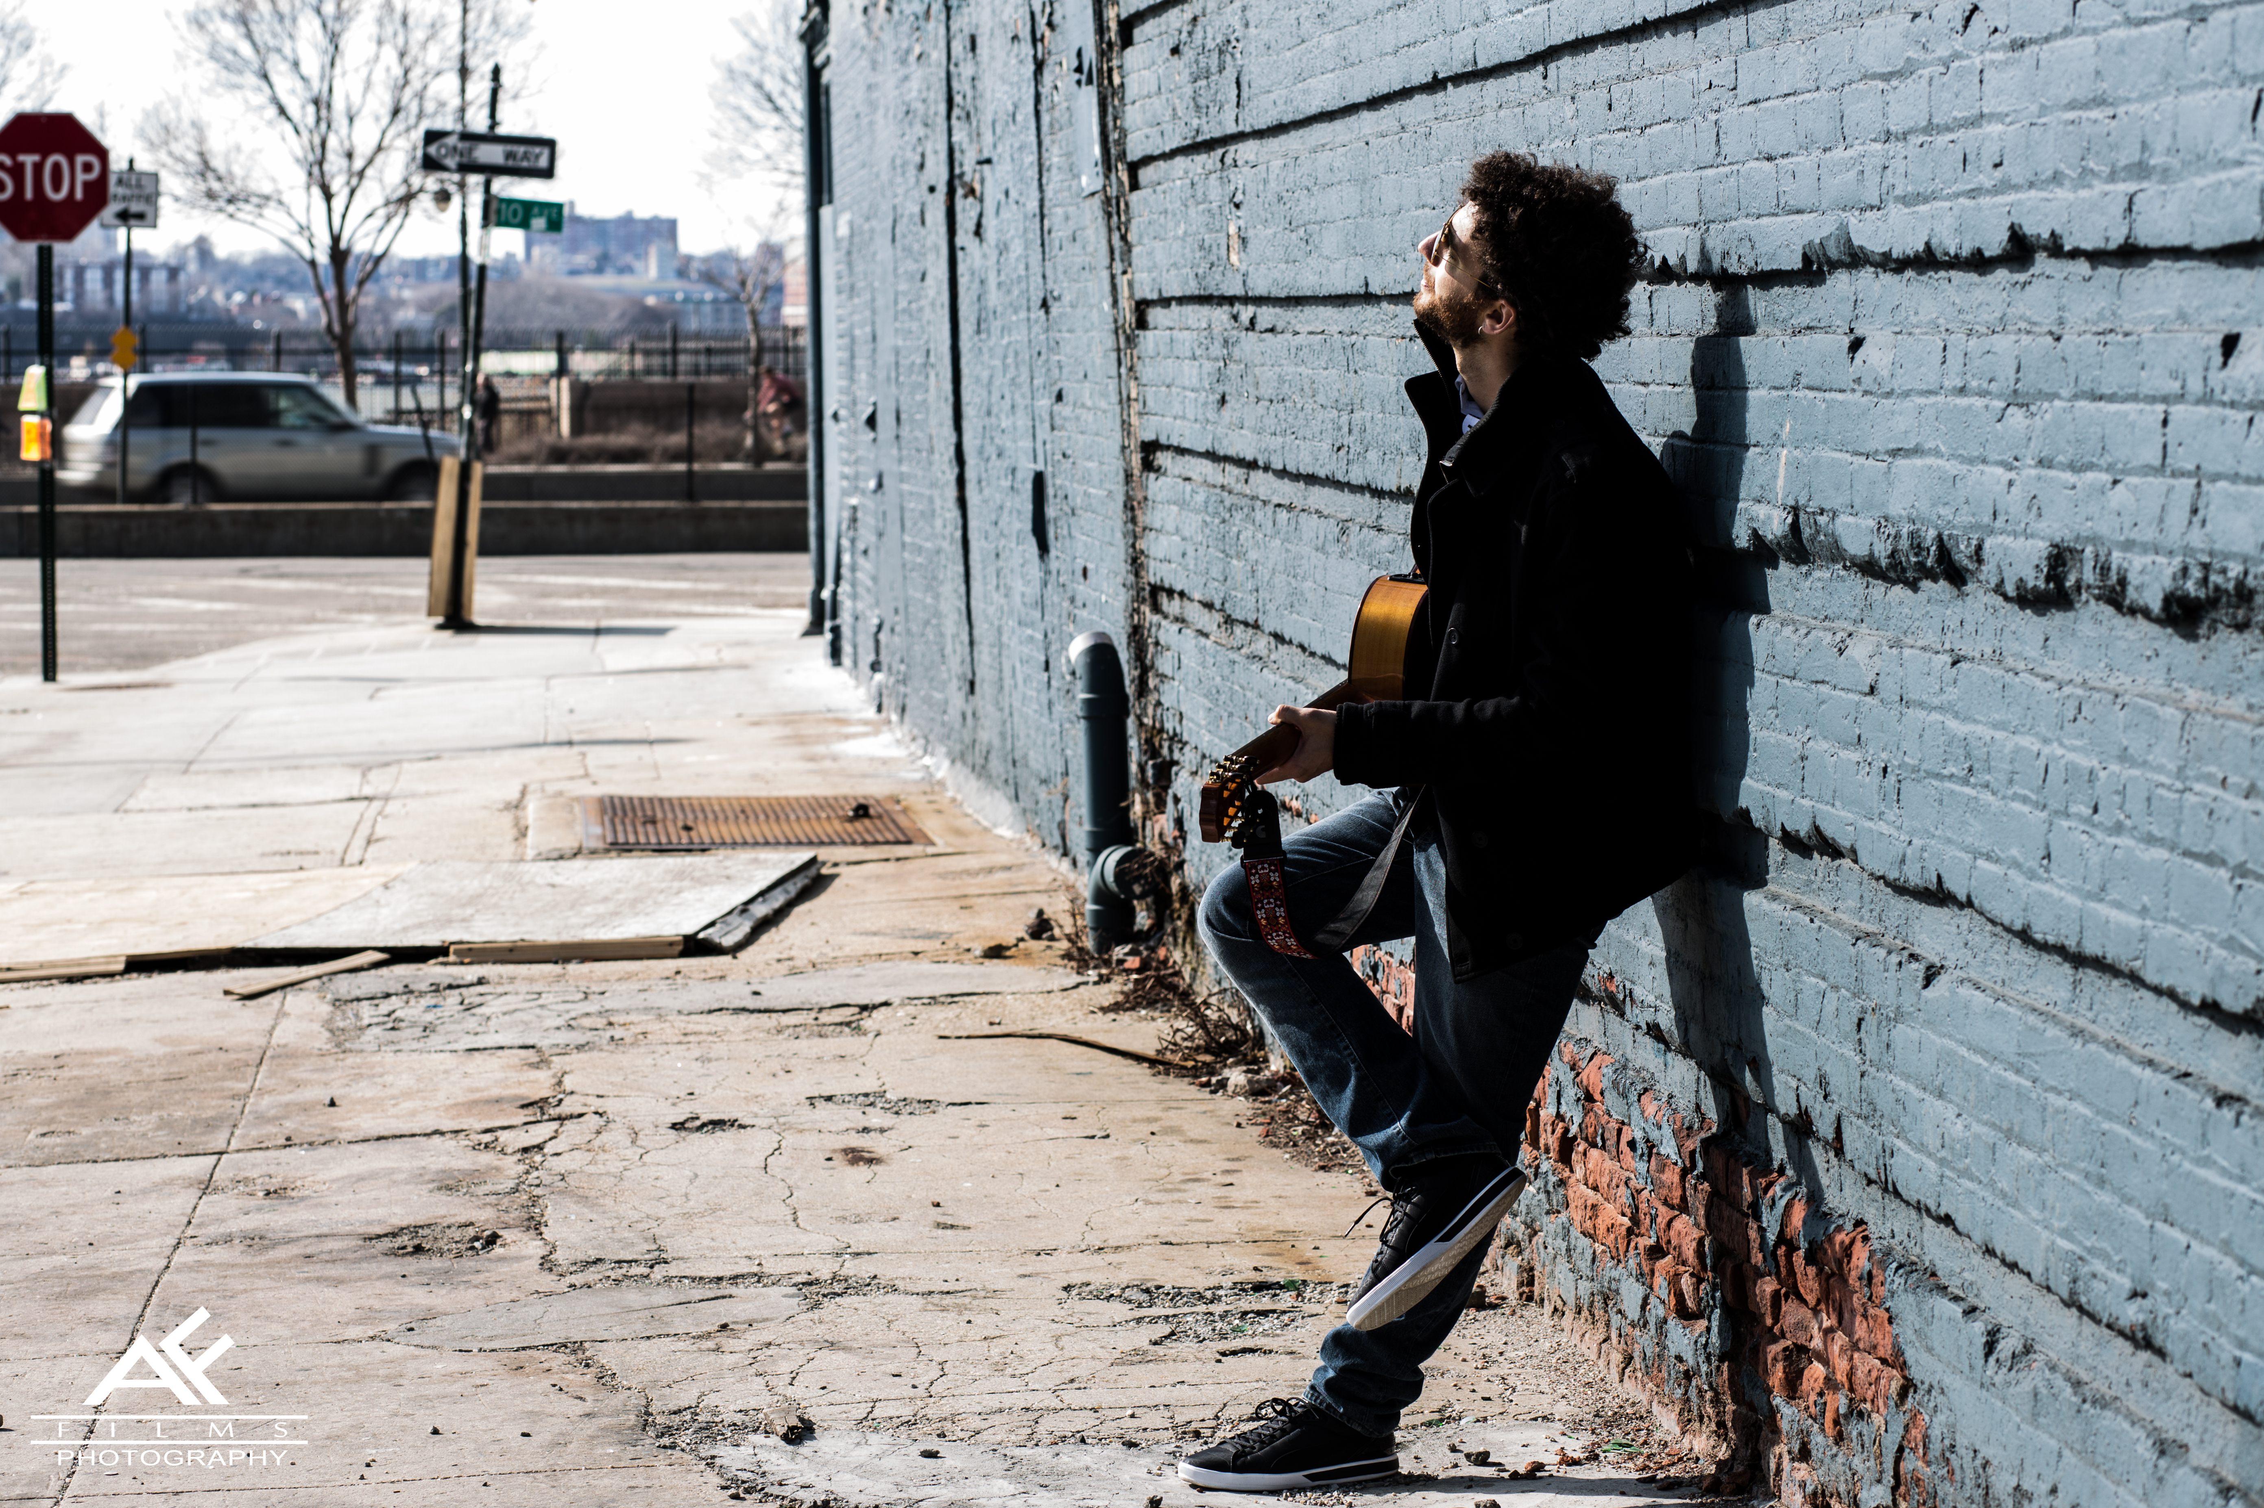

„It was so captivating
I swear you could barely hear anyone breath..!“
(a fan)

Sebastián Pecznik is a young and charismatic Argentinian-Polish guitar player, composer and arranger, home based in Berlin, Germany. His international live perfomance career is spectacularly documented by various numbers of venues and festivals he has already performed at.

When on stage he captures the heart of the audience in the first moment, as he starts a dialogue, not only through his emotional and virtuous music but also through the fascinating stories he tells. His music can as easily fill philharmonic halls, concert theaters, as well as petit venues and concert cafés.

​Having received 6 awards and letters of merit from the Argentinian Chancery and the General Bureau of Cultural Affairs, declaring his concerts, master classes and tours of "highly artistic & cultural value", he has been touring through Europe more than five times in the last ​5 years, and has also performed twice in New York at the beautiful BPAC (Baruch Performing Arts Center). Pecznik has been and will be sponsored by Argentinian Embassies all over the world.

CDs
Tango sensations & Other Moments of the Day
Piazzolla by Pecznik
Tales from the South

Live-Programs

Piazzolla by Pecznik
Sebastian Pecznik invites you to a journey that will guide you
through the most significant works of the grand master Astor Piazzolla; where
the guitar and Sebastians stories about the creation of some of the pieces, create
an intimate and moving concert where the mood flows between Tango, Jazz and
Classical guitar.

Tango Sensations & Other Moments of the Day
Sebastian Peczniks first solo work for cassical guitar invites you to a
musical journey that will guide you through a delicate & passionate selection of
the pieces that shaped the Tango Histrory, including works by Carlos Gardel,
Anibal Troilo & Astor Piazzolla.

Latin American Music for Guitar
Featering works of Agustin Barrios Mangore, Leo Browuer, Astor Piazzolla, Heitor Villalobos, Sebastian Pecznik, Atahualpa Yupanqui, & more!

Classical Guitar
Bach, Chopin, Piazzolla,Pecznik, Villa Lobos, Tarrega Barrios, Browuer,
Rodrigo & many more

Concerts (selection)

Munich Kino Kabarett Festival, Germany
Lublin KinoEaters Film Festival, Poland
Uppsala Guitar Festival, Sweden
(2015 Support artist for world wide renowned Xue Fei Yang)
MOON PALACE ARENA, Cancun, Mexico
(16 shows with Franc D´Ambrosio & Brian Boitano for Broadway on Ice)
Rzeszow Philharmonic Hall, Poland
Koktebel Jazz & World Music Festival, Ukraine
Berlin Latin Short Film Festival​ at Babylon Kino, Germany
Mendelssohn Haus, Leipzig, Germany
Baruch Performing Arts Center New York, USA
House of Culture Cantabria, Spain
Le Maisson Argentine, Paris, France
Kiwara Lodge, Leipzig, Germany
Schwarzberg, Vienna, Austria

Press Contact:

